Practical 10

Definition : Create a Dashboard using IBM cognos.
Outcomes / Learning : Learned to select appropriate data visualizations and configure their properties to build a comprehensive, interactive business dashboard in IBM Cognos.
Required Tool : The Experiment was performed using IBM Cognos Analytics.
Working : Created an interactive dashboard by linking various data visualizations (Line Chart, Pie Chart, List, Radar Graph) to a sample sales and marketing dataset.

Step 1: Select Dashboard > Blank Dashboard to start a new project.
Step 2: Select Source > Samples > Data > Coffee Sales & Marketing to load the dataset.
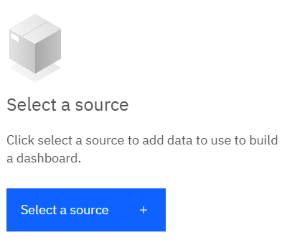
Step 3: Access the Visualization Tab on the left to select widgets.
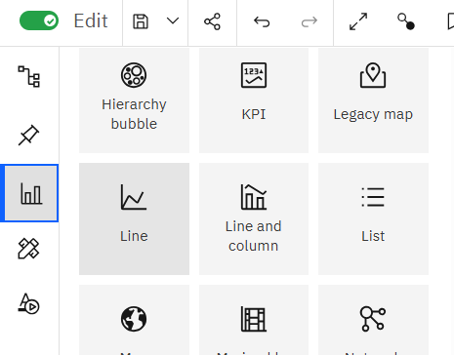
Step 4 (Area Chart) : Configure Area Chart with 'Beverages' on X axis and 'Sales ‘&’Quantity' on Y axis
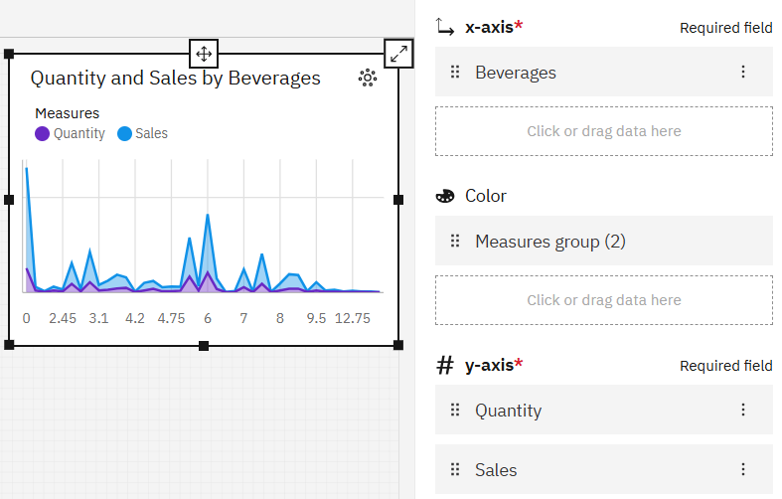

Step 5 (Line & Column Chart) : Configure Line & Column Chart with 'Beverages' on X axis, ‘Sales' on Column Length and 'Quantity' on Line Position
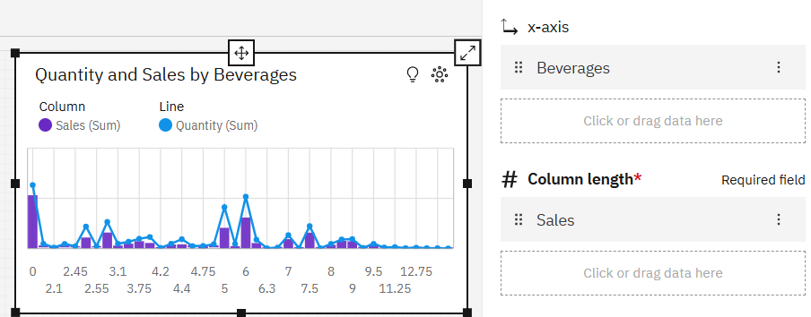
Step 6 (Scatter Chart) : Configure Scatter Chart with 'Sales' on Points, 'Beverages ‘&’Food' on X Axis and 'Quantity' on Y Axis
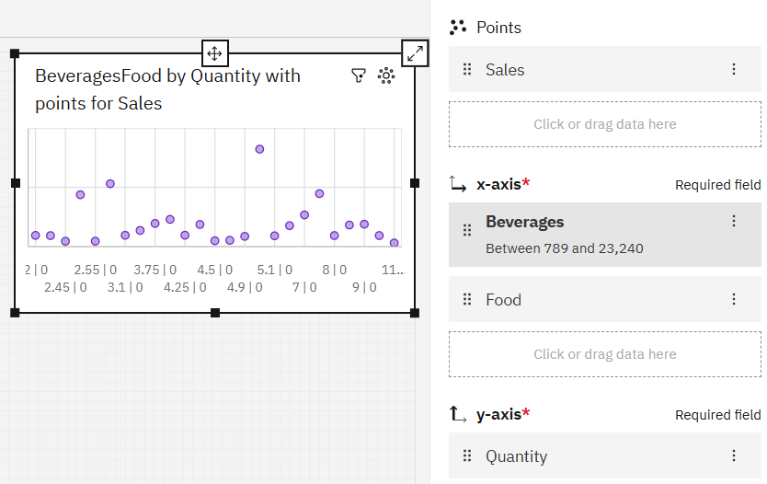
Step 7 (Pie Chart) : Configure Pie Chart with 'Beverages' on Segment and 'Sales' on Size
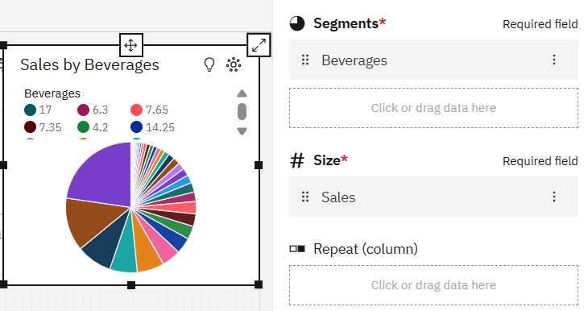
Step 8 (Radar Chart) : Configure Radar Chart with 'Spoilage Expense' on Categories and 'Spoilage' on Values
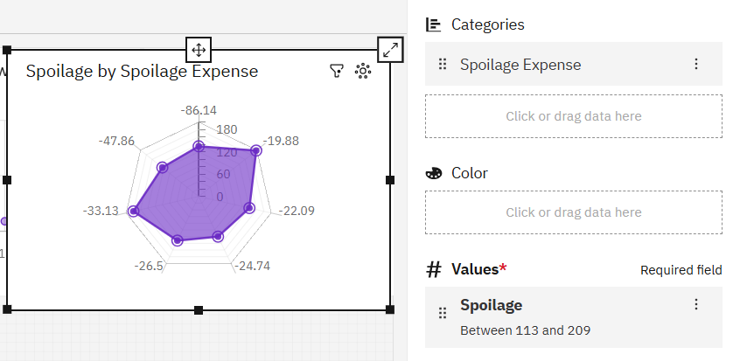

Step 9 (Sun Burst Graph) : Configure Sunburst Chart with 'Beverages' on Target
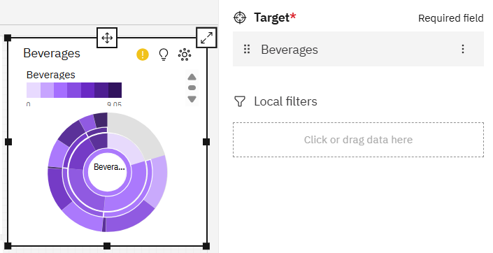

Step 10 : In The Left, Toggle The Edit Button to Preview Your Interactive Dashboard
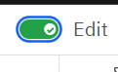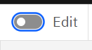

End Result :
